All Disease begins in the Gut
Gut and Psychology Syndrome
By Dr.
I feel at times the world is spinning hopelessly out of control. I wish we could make everyone and everything stop so we could take a few deep breaths and reason together. Can’t we see that we are poisoning our earth and with it those we love? There are too many casualties in too many battles. We are repeatedly told that technology is advancement. We are able to dissect the genome and gaze at infinitesimal molecules, but as leaders (the USA) in the technological world, we have one of the poorer records for health. Research from the United States indicates that over the past 20 years childhood diseases and disorders have skyrocketed with Allergies up 700%, ADHD up 500%, Asthma up 300% and Autism up 1500%! Ten years ago, 1 in 10,000 children were diagnosed as autistic. Today, 1 in between 120 and 1 in 250 (depending on the study and region looked at) children are diagnosed with autism. In California there has been a 10-fold increase in newly diagnosed cases in the last 10 years and the trend is rising. It is estimated that today in California rates of autism are increasing by 1 child every 3 hours. About 10% of the children in the United States are diagnosed with ADHD/ADD or learning disabled. As these children move from childhood to adulthood they are more prone to be diagnosed with schizophrenia, obsessive-compulsive disorder (OCD), bipolar disorder, depression or other mental illnesses.

This rising trend is not simply because we are better at diagnosing or we have broadened the parameters of these conditions to include more children. As I see it, we have a full-blown crisis on our hands and the tools that have created the problem are not likely to be the ones that fix it. Yet, this is where the lion's share of all research dollars are being spent in our country; namely pharmaceutical cures. Let me offer another solution or scenario that may help explain what is going on and how we may turn many of these conditions around giving children a normal healthy life.

It is the current thought among researchers and doctors who are not being funded or manipulated by the pharmaceutical or chemical industries that repeated exposures to unnatural drugs and toxins are poisoning and damaging our bodies. The father of medicine, Hippocrates, cautioned (back before drugs ruled the day) that, “ALL Disease begins in the Gut”. Could the words of a wizened sage still hold true today. Let’s unfold what some of the current research is revealing.

It has been found that bottle fed babies develop a completely different and less healthy gut flora than breast fed babies. The compromised gut flora in a bottle-fed baby later on predisposes her to many health problems. Having acquired a weakened gut flora from the start, the typical modern mom had quite a few courses of antibiotics in her childhood and youth for various infections, earaches or acne. It is a well-known fact that antibiotics have a serious damaging effect on the gut flora, because they wipe out the beneficial strains of bacteria in the gut as well as the harmful ones.

Many modern moms had been on birth control pills for many years before getting pregnant. Birth control pills have a devastating effect on the beneficial (good) bacteria in the gut. One of the major functions of the good bacteria in the gut flora is controlling and managing over 500 different species of pathogenic (bad) and opportunistic microbes. When the good bacteria are destroyed the opportunistic microbes multiply in large colonies and occupy large areas of the digestive tract. A modern diet of processed and fast foods provides the perfect nourishment for these colonies of bad microbes. As a result of all these factors, a modern mom has a seriously compromised gut flora by the time she is ready to have children.

Why are we talking about the mother’s gut flora? Because her baby is born with a sterile gut. In the first 20 days or so after the birth of the child, the baby’s sterile gut surface gets populated by a mixture of microbes, which comes from the mother. So whatever microbial flora the mother has, she will pass on to her newborn child.

If the child does not acquire a normal balanced gut flora, then the child will not digest and absorb foods properly, developing multiple nutritional deficiencies. Malnourished patients demonstrate learning disabilities, psychiatric problems and allergies. The properly balanced gut flora actively synthesizes various nutrients such as vitamin K and many of the B-vitamins. Clinical experience shows that the best way to treat these deficiencies is to restore the beneficial bacteria to the gut. Remember, there must be a symbiotic balance of the good as well as the bad microbes in the gut. You must supply the good as the bad microbes are ever present.

In addition to nourishing the body, the beneficial bacteria in the gut act as the housekeepers of the digestive tract. They coat the entire surface of the gut protecting it from invaders and toxins by providing a natural barrier and producing a lot of anti-bacterial, anti-viral and anti-fungal substances. It is no surprise that when the gut flora is out of balance, digestion cannot be healthy. Again, there is a direct connection between digestive problems and learning disabilities, psychiatric disorders, allergies and a weakened immune system.

If a baby does not acquire appropriate gut flora, then the baby is left with a compromised or weakened immune system. The result is a history of infections followed by courses of antibiotics, which damage the child’s gut flora and immune system even further. Infections such as ear infections, chest infections, fevers, sore throats and skin rashes are common. Many children that I see in my practice have had antibiotic therapy 4 and 5 times per year for several years. Vaccinations given to a child with a compromised immune system can further weaken the immune system and provide a source of chronic persistent viral infections and autoimmune problems in children.

So, the modern child, who we are talking about, did not get normal gut flora from the start and then damaged it further with repeated courses of antibiotics and vaccinations. Is it any surprise that digestive problems, allergies, asthma, eczema, and a variety of neurological and psychological disorders are so common today? I think it is inaccurate to look for a single causative factor for these conditions, when in fact, there appears to be a multiplicity of causes that have culminated into the epidemic we now face.

The average adult has about 4 pounds of bacteria in the gut. In fact, the number of microbial cells in the gut outnumber the number of cells in your entire body. Good microbes aid in the digestion of food. They synthesize various nutrients, they protect the gut from toxins and pathogenic bacteria, yeast and fungi that can affect brain function and they support production of different immune supporting cells. Without control of the beneficial bacteria, the person’s digestive system, instead of being a source of nourishment, becomes a major source of toxicity in the body.

Powerful neurotoxins created from yeast such as Candida and Clostridia can get absorbed through the damaged gut lining and then cross the blood-brain barrier affecting the patients mental functioning. Broad-spectrum antibiotics do not touch them while killing the beneficial bacteria in the gut, which are supposed to control and manage the yeasts and clostridia. So after a course of antibiotics, these two pathogenic groups get even more out of control and grow stronger. Clostridia overgrowth in the gut has also been associated with obesity, which may explain why it can be so difficult for some to lose weight.

Because of these imbalances in normal gut flora, children and adults, as well, are unable to properly breakdown and digest some common foods. Poor digestive health is also behind the growing trend towards gluten and dairy-free diets. Many have learned, simply by listening to their bodies, that they do not do very well if they eat grains or dairy. When the gut flora is out of balance, large proteins such as gluten and casein are difficult to breakdown and digest. Gluten is a protein present in grains, mainly wheat, rye, and barley. Casein is a milk protein present in milk products of all animals. In gut dysbiosis (which literally means a bad condition of life), these proteins do not have a chance to be digested properly before they get absorbed into the blood stream. They are absorbed into the bloodstream in a form with a similar chemical structure to opiates, like morphine and heroin. These substances called gluteomorphin and casomorphin get through the blood-brain-barrier and block certain areas of the brain just like morphine or heroin would do, causing various neurological and psychological symptoms. These substances, gluteomorphin and casomorphin, are routinely found in the urine of patients with schizophrenia, autism, ADHD, depression as well as rheumatoid arthritis.

Autism, ADHD, dyslexia, dyspraxia (poor coordination), schizophrenia and many other learning and mental problems are not incurable. There are hundred of documented cases of recovery from autism, ADHD/ADD and schizophrenia when the child was given the right treatment. Again, the solution many parents are finding is not as simple as taking a new drug or a super supplement. There often must be a comprehensive approach. But while there will be some effort and inconvenience involved, the benefits can be transforming and life-giving.

Dr. Kenneth Bock, a New York-based physician and author of Healing The New Childhood Epidemics: Autism, ADHD, Allergies & Asthma explains; “we are in the midst of a group of new childhood epidemics, which are directly related to industrialism, and to its associated pollution, environmental degradation, and toxicity.” Included in the list of offenders are pollutants, as well as, chemicals in foods that the body is not able to metabolize. An overload of toxins leads to chemical stress in the body, that in turn, creates chronic inflammation in the lungs (asthma), in the immune system (allergies), in the brain (attention deficit), and in the skin (eczema). There appears to be a direct correlation relating specific digestive disorders to conditions such as schizophrenia, autism, attention deficit disorder, attention deficit hyperactivity disorder, and bipolar disorder.

A comprehensive treatment approach focuses on treating each individual on the cellular level, ensuring that each cell has proper nutrition and is not over-burdened by toxins. By repairing the digestive tract, adopting the right diet, taking nutritional supplements and detoxifying, the cells become more effective at supporting all organ and body systems.

Again, the father of medicine, Hippocrates, cautioned, “ALL Diseases begin in the Gut”. For this reason, it is important that we work to restore digestive health rather than just treat the symptoms. Medication protocols focus primarily on modifying symptoms rather than addressing the underlying causes. Re-establishing normal gut flora can address a myriad of health issues. The treatment described in Dr. Natasha Campbell-McBride’s book Gut and Psychology Syndrome is not drug based. Her treatment is a natural nutritional approach, which changes the child’s diet, supplementation and lifestyle.

A major part of recovery is modifying the diet to eliminate or reduce dietary stress. The appropriate diet is key to allowing the digestive tract to heal and allow for the re-establishment of the good bacteria. One of the great challenges for introducing any diet into a child’s life is the fact that the majority of children with learning disabilities are extremely ‘picky’ eaters. Part of their problem is that their diet is limited to a handful of foods, which only perpetuates their biochemical and physiological abnormalities.

The rapid industrialization of food, medication, communication and lifestyle has challenged our bodies, which have not been able to adapt as quickly. A focus on nutrition, non-toxic home and personal care products and a low stress lifestyle can facilitate the healing and recovery of those affected with GAPS (Gut and Psychology Syndrome) as Dr. Campbell-McBride has coined it. We all need clean air, clean water, clean soil, wholesome food and fun.

The GAPS children and adults can present symptoms of autism, ADHA, ADD, OCD, dyslexia, dyspraxia, schizophrenia, depression, bipolar disorder, sleep disorders, allergies, asthma and eczema in any possible combination. Any child or adult with a learning disability, neurological or psychological problems and allergies should be thoroughly examined for gut dysbiosis. Re-establishing normal gut flora and treating the digestive system of the person should be the number one treatment for these disorders, before considering treatment with drugs or otherwise.

Please take a moment to evaluate yourself and your children for any symptoms of gut dysbiosis. Constipation (less than 2 to 3 bowel movements daily), diarrhea, eczema, asthma, allergies, indigestion, excessive gas or burping, tummy aches or pains.

Often the first step is to eliminate foods that are potentially risky. Eliminating gluten and milk products, which may seem dramatic or difficult can be easily done with a little planning. Most large grocery stores have a gluten-free section. Use rice or almond milk instead of cow, goat or soymilk. Avoid foods with chemical additives or preservatives. Eat foods that are abundant in good bacteria such as sauerkraut (homemade or in the refrigerated section of the health food store). I have found that even you picky eaters can develop a taste for mildly fermented vegetables. A good probiotic supplement is recommended. Digestive enzymes can also be beneficial.

If constipation is an issue take a Colon Cleansing/ herbal laxative formula adjusting the amount you take until you are stable with 2 to 3 bowel movements daily. If your bowels are too loose, give a Colon Detoxing formula with bentonite clay a try. These Colon Detox formulas have benefited many who have suffered from Irritable Bowel Syndrome, Colitis and even Crohn’s Disease. Building the immune system will be important if you are prone to getting ill. Take an Echinacea based Immune Formula (teen and adults) or Syrup (for infants and children) for 6 to 8 weeks, getting away from the repeated cycles of antibiotics.

Remember, symptoms are the body’s way of letting you know something is wrong. Please take stock of your current level of health and of those you love. I urge you to take pen to paper and draft a plan. As you know, a goal not written, is only a wish. Getting healthy can be as simple as putting the good things into the body and removing the bad. Nourish and detoxify. To that end, we can assist you.

With Infinite Love and Gratitude,

Kyle D. Christensen, DC, ND, MH

This is how I make Fermented Vegetables/Sauerkraut

Air-Lock Lids

Making your own fermented or naturally cultured vegetables is easy, but you need the right tools to ensure consistent success. After struggling for months trying to get a reliable source of jars with air lock lids, we finally resolved to make our own. The design is simple and best of all works with wide-mouth canning jars.

Using your Air-Lock Lid
Fill your canning jar with vegetables to the shoulder (where the jar curves toward the mouth of the jar). Pack your vegetables down as firmly as you can. You may use a “Kraut Pounder” or any blunt wooden object. Give you a good inch or so to the rim. Pour your brine (water with sea salt added – 1TBS sea salt for 2 cups of water makes a 3.6% brine) into the jar covering the vegetables. There should be about 3/4 – 1 inch of brine above the vegetables. You may add to your brine a packaged culture starter, such as Caldwell’s. This introduces a very specific array of good bacteria. Or you may add some brine from a previous batch of cultured or fermented vegetables. You can use fresh whey or often I use nothing at all relying on the natural lactobacillus bacteria that is found on the surface of the vegetables. All of these work just fine.

You may use marbles or pieces of ceramic to hold the vegetables down keeping them submerged under the brine. However if your jar is full, this won’t be necessary. The more salt you add the slower will be the fermentation process, the less salt, the faster things will ferment. Your brine can range from 1 to 4 Tablespoons per quart of purified water.

Once your vegetables are situated and tucked in, place the air-lock lid with the red gasket in place over the rim of the jar. Screw on the ring from your canning jar to secure the lid in place. Remove the plastic cap from your air-lock. Notice there are small holes around the perimeter of the cap – this allows the carbon dioxide (CO2) to escape from the air-lock once the fermentation of the vegetables begin. Fill the air-lock with water to the midway line. The water is what creates the barrier preventing mold spores or other contaminants from getting in to your vegetables. Carbon dioxide is allowed to escape but nothing is allowed to come in. Moisten the tip the of air-lock and/or grommet (the black center hole in your lid) and press and twist the air-lock into the grommet until it is secure.

Ta Da! You’ve done it! Keep your fermenting jar in an out of the way place on your counter out of direct sunlight. We typically allow at least 3 weeks for the fermentation process to be done enough to start eating. However, some schools of thought want at least 6 weeks and some as much as 6 months. For those who have not acquired a taste for sauerkraut or cultured vegetables yet, you can pull your jar and refrigerate after 4 days and begin enjoying it. It will be mildly fermented. Refrigeration will drastically slow the fermentation process. When your fermented veggies are ready. (You decide when.) Replace the airlock lid with a regular canning lid or a plastic canning jar lid. We always recommend that you label your jars – Come on give it a real fun or fancy name, list the ingredients and the date. This is your creation, have fun with it.

Enjoy your journey to better health!!

Fermented Vegetable Recipes

Basic Sauerkraut Recipe
Green Cabbage, cored and shredded
1 Tsp caraway seeds or juniper berries per quart that is being made
1 TBS Sea Salt
Brine as needed.
In a bowl, mix cabbage with caraway seeds, sea salt and whey. Pound with a wooden pounder or a meat hammer (non-metallic) for about 10 minutes to release the juices. I used to pound my cabbage, but rarely do so anymore. The salt and the brine will do this job, so I typically mix everything thoroughly and pack my jar or crock tightly. Place in a quart/half gallon or gallon size jar. Press firmly with you pounder cover the packed cabbage with brine until covered by 1 inch of liquid. The top of the cabbage should be a least 1-inch from the top of the jar. Cover tightly and keep at room temperature for about 4 days to 6 weeks before transferring to cold storage. The sauerkraut may be eaten immediately, but improves with age.

Cortido – Latin American Sauerkraut – this is my favorite
Green cabbage, carrots, onion, dried oregano, chili powder or red pepper flakes, sea salt, lactic starters*.

Bean Salad – this is a take on the traditional three bean salad – Very Delicious!
Green beans, garbanzo beans, red or kidney beans, navy beans (previously soaked and cooked until soft), onions, carrot, celery, parsley, cilantro, mustard (dry powder or whole seed), parsley, sea salt, lactic starters*.

Scarborough Fair Sauerkraut (like the song “parsley, sage, rosemary and thyme”)
Green cabbage, onion, carrot, parsley, sage, rosemary and thyme, sea salt, lactic starters*.

Beets – this is the best – the tarragon is brilliant
Beet, spring water, green cabbage, sea salt, aniseed, tarragon, whole pepper, ginger, nutmeg, clove, lactic starters*.

Cultured Beets – we love the cumin and beet combination
Beets, carrot, oinio, cumin, garlic, oregano, lemon peel marjoram, black pepper, sea salt, water, lactic starters*.

Carrots – a basic staple
Carrots, green cabbage, onion, spring water, sea salt and lactic starters*.

Carrots with Chocolate Mint – Surprisingly fresh – no real chocolate
Carrots, chocolate mint, spring water, sea salt, lactic starters*.

Sauerkraut RED – pretty traditional but very different from its green sister
Red Cabbage, spring water, sea salt, fresh garlic, bay leaves, and lactic starters*.

Carrots – the nutmeg, coriander, clove and ginger add a richness that will surprise you.
Carrots, cabbage, onion, spring water, sea salt, mustard seeds, coriander seeds, peppercorns, nutmeg, ginger, cloves and lactic starters*.

*Lactic Starter: whey, brine from a previous batch, a pinch of Caldwell’s Culture or even a probiotic capsule broken open and mixed in. Often we don’t use anything. There is enough lactobacillus bacteria naturally found on the vegetables that your fermentation will go just fine without a starter.

So here’s the real truth about what goes into our jars. We ferment whatever we have got and wherever is ripe. If we’ve got it, it is fair game for the pickle jar. Experiment and play around with different combinations, herbs and spices. Have fun with this.

Homemade Yogurt
Yogurt, also spelled yoghurt or yoghourt, is a thick, custard- or pudding-like food, made by the natural bacterial fermentation of milk. Many people enjoy it plain or flavored with breakfast, lunch, or as a snack, as well as being an ingredient in a number of other dishes.

The process of making yogurt involves fermenting cream or milk with live and active bacterial cultures; this is accomplished by adding bacteria directly to the dairy product. Commercial varieties are usually made with a culture of Lactobacillus acidophilus and Streptococcus thermophilis, although some manufacturers use Lactobacillus bulgaricus rather than L. acidophilus.
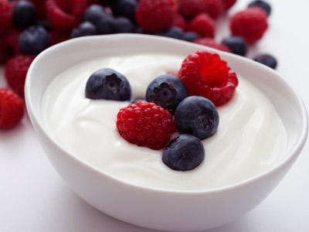
In Western cultures, yogurt is enjoyed in a variety of ways, most popularly as a cool dish mixed with fruit. It can be used to make healthy shakes or frozen to eat like ice cream as well. Yogurt can also be used when cooking, in place of milk, sour cream, and even some cheeses. In Middle Eastern cultures, it's frequently served with meat, meat sauces, and vegetables. It can also be mixed with various other sauces or used as a tangy dollop on top of a meal.

Ingredients:
1 Half gallon to a gallon of milk (we like whole milk, raw milk, or even powdered milk)
From Powdered Milk blend 2 ½ cups of powdered milk to 7 cups of water)
2-3 Tbs. of plain yogurt (as a starter)

Equipment:
- An 8-10 qt.stock pot – we use ours from the wonderbox because that is where we let the yogurt cure.
- thermometer
- Wonderbox or thermal cooker - A wonder box is a heat retention cooker. After you bring your food to a boil or up to temperature (so it is heated throughout) using any number of cooking methods, you remove it from the heat source and quickly place the pot inside the wonder box. The insulation of the wonder box will slow your food’s loss of heat keeping at cooking temperatures for hours. Using a wonder box reduces the amount of fuel needed to cook your meal because the fuel that would normally be used to keep your food at cooking temperatures after it has started boiling is eliminated.

Directions:
  - While you can use raw milk, it is often recommended that it be pasteurized or heated to 185°F. When using organic milk for the grocery store or making milk from powdered, it is not necessary to pasteurize the milk.
  - Cool the milk to 110°F using a cold water bath or bring it up to 110°F, stirring to avoid a skin forming.
  - Pour 2-3 Tbs. of plain yogurt into 110°F milk and stir well.
  - Place pot with lid into the wonderbox and tuck it in for the night
  - In the morning, wake up to wonderful set-up yogurt.
  - Refrigerate to completely chill. Add honey, jam or fresh fruit to eat.

Greek Yogurt
We hear that Greek Yogurt is better for you, but no one talks about why. We know Greek yogurt is thicker than traditional yogurt, but that’s about it.
First of all, there is a difference between Greek yogurt and “Greek-style” yogurt. “Greek-Style” Yogurt is usually traditional yogurt with thickening agents added. True Greek yogurt which is what we are interested in, is thickened by straining much of the whey from the curds or milk solids.
Both traditional and Greek yogurts start out the same — by fermenting milk with live bacteria cultures. Greek yogurt is created when the yogurt is strained so that the liquid whey is removed. When the whey is gone or reduced, the yogurt takes on a thicker, cheesier texture than traditional yogurt.
For traditional yogurt, if a cup of milk is used to make the yogurt, one cup of yogurt is produced. In Greek yogurt, it takes more milk to create one cup of yogurt, sometimes up to four cups of milk. This is why true Greek yogurts can be more expensive.

Directions for Greek Yogurt
Make you own Greek yogurt, by pouring your finished yogurt from the pot into a double or triple layered paint strainer. We like paint strainers (From Home Depot or paint supplier) way better than crummy old cheesecloth. Hang the strainers so the whey can drain for about 3 to 6 hours. Capture the whey because this can be used in making your fermented vegetables, making ricotta cheese or feeding to the chickens.

Yogurt Dream Cheese (aka Cream Cheese)
Similar to making Greek Yogurt. Pour your finished yogurt into the double layered paint strainer and hang to capture the curds and release the whey. Keep hanging for 12 to 24 hours. Remove from strainers and stir in 1 teaspoon of sea salt per 4 cups of Greek Yogurt. Return to the bag and hang for another 4 – 24 hours (the longer the firmer the cheese). Remove and enjoy. Keeps for 1 week refrigerated.

Shankleesh (or Dream Cheese in olive oil)
Popular from Greece to Israel and from Palestine to Iran, Shankleesh is the arabic name for this cheese.
Use a firmer Dream Cheese as it will hold better together in the olive oil. Dollop about 2 TBS of dream cheese onto a plate of herbs – classically this cheese is made dredged in the herb/spice blend call zaatar (thyme, sesame, sumac and oregano), but we like Mountain Rose herbs blends of Mexican or Mediterranean Seasoning. Roll into a ball that is completely dredged or covered with the herb.
Submerge the herbed cheese ball in olive oil. Fill up the jar half way with olive oil and carefully lower the balls into the oil. The olive oil should completely cover the cheese balls. Add more oil as necessary.

Age the cheese
This cheese keeps beautifully at low temperatures. It can be aged a minimum of 1 month and a maximum of 8 months. Keep in a cool environment (basement or cellar).

The olive oil will keep the cheeses from being exposed to air that will degrade them. As long as the cheese is dry enough, they will stay submerged in the oil; and as long as they stay submerged they will be preserved. Two reasons cheese might rise are that the aging environment is too warm and that high moisture content in the cheese caused continued fermentation and the production of gases that give unwanted buoyancy, If the cheeses rise to the surface, they are not safe to eat. This recipe is from The Art of Natural Cheesemaking by David Asher.

Serve Shankleesh with crackers or as a spread.

DeGrey Christensen, Kyle Christensen, 2017

Kefir
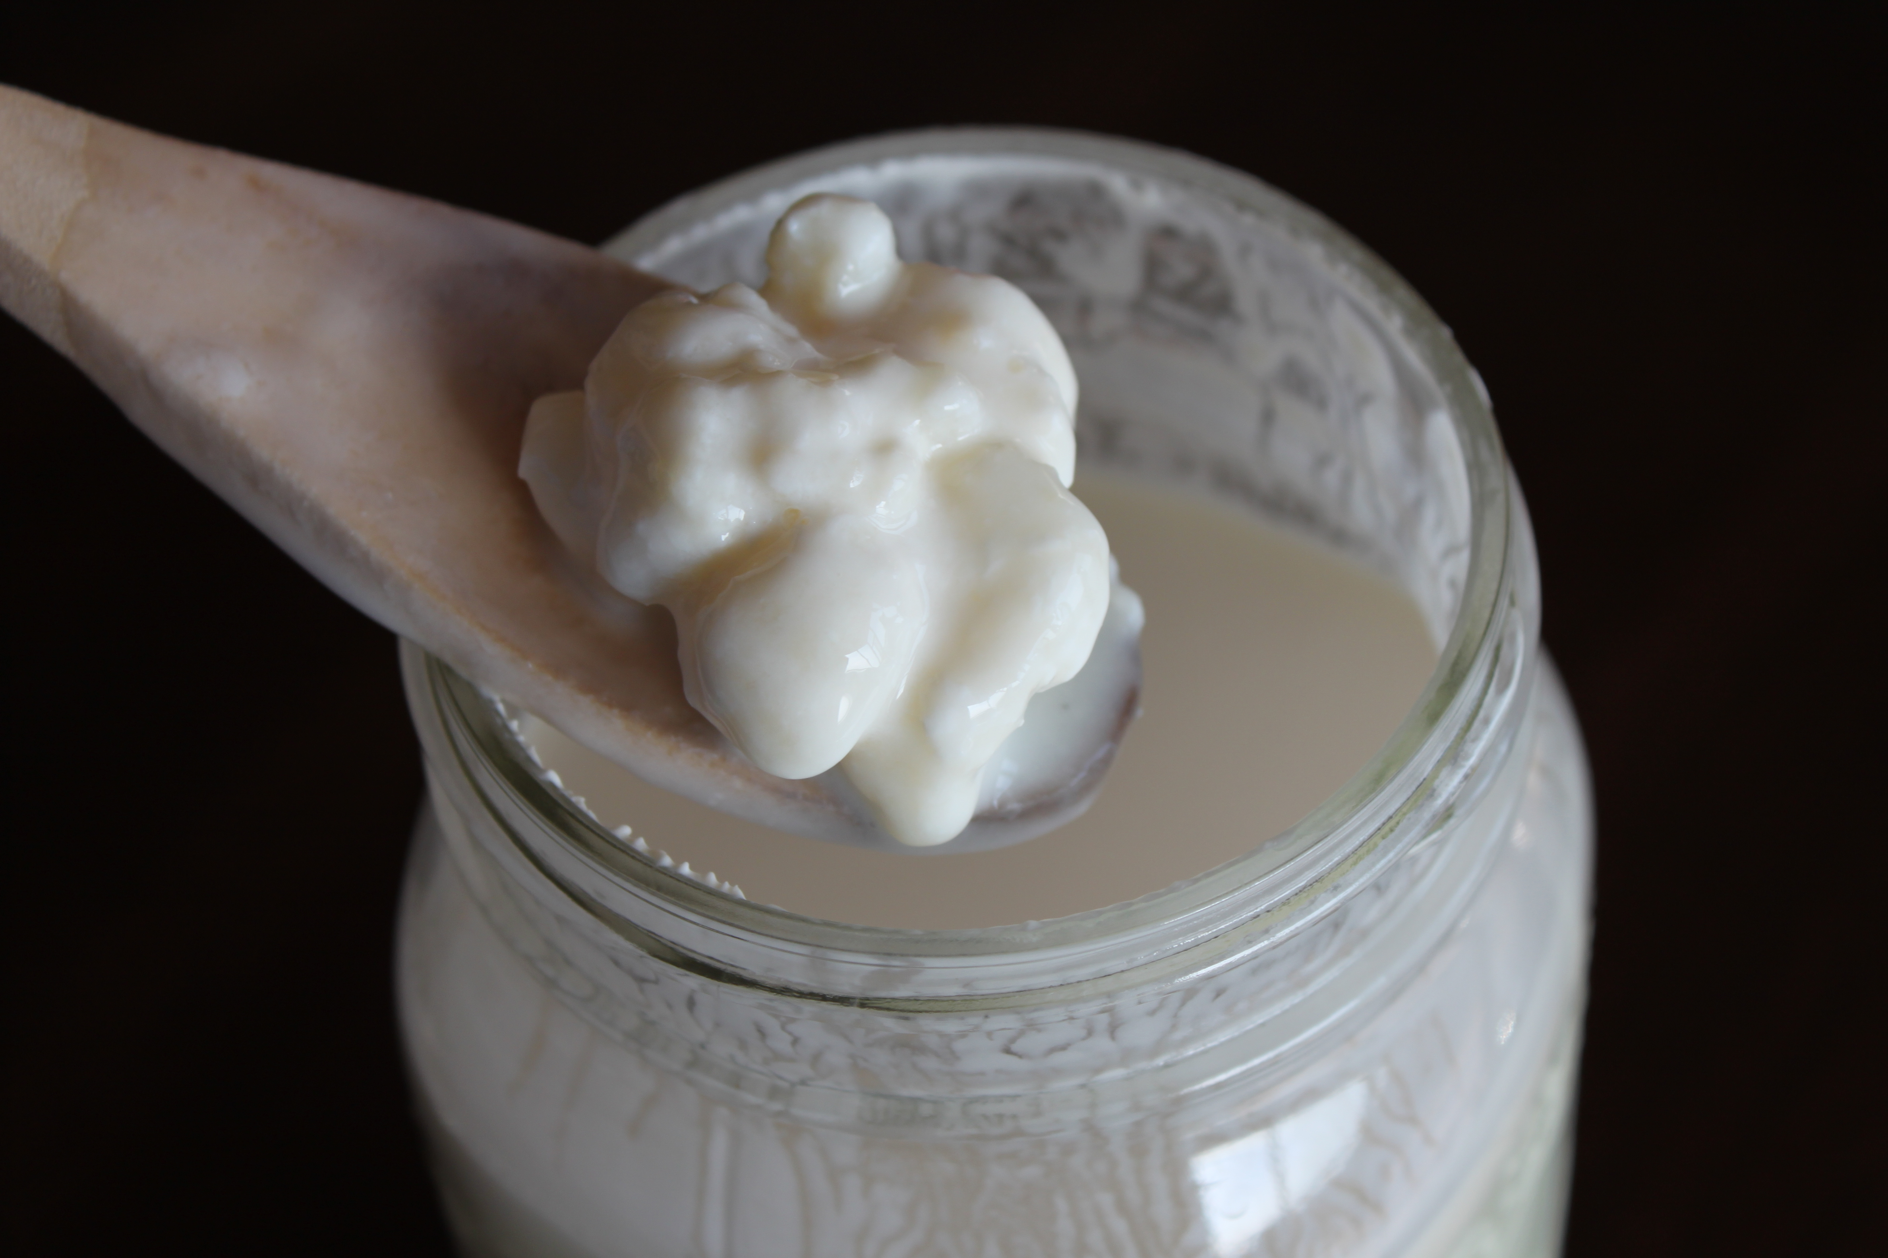
Kefir’s tart and refreshing flavor is similar to a drinking-style yogurt, but it contains beneficial yeast as well as friendly ‘probiotic’ bacteria found in yogurt. The naturally occurring bacteria and yeast in kefir combine symbiotically to give superior health benefits when consumed regularly. It is loaded with valuable vitamins and minerals and contains easily digestible complete proteins.

How is Kefir Made?
Kefir can be made from any type of milk: cow, goat, sheep, coconut, rice or soy. Although it is slightly mucous forming, the mucous has a “clean” quality to it that creates ideal conditions in the digestive tract for the colonization of friendly bacteria.

Kefir is made from gelatinous white or yellow particles called “grains.” This makes kefir unique, as no other milk culture forms grains. These grains contain the bacteria/yeast mixture clumped together with casein (milk proteins) and complex sugars. They look like pieces of coral or small clumps of cauliflower and range from the size of a grain of wheat to that of a hazelnut. Some of the grains have been known to grow in large flat sheets that can be big enough to cover your hand!. The grains ferment the milk, incorporating their friendly organisms to create the cultured product. The grains are then removed with a strainer before consumption of the kefir and added to a new batch of milk.

Kefir - continued
Ingredients:
1 tablespoon kefir grains (looks like little pieces of cauliflower) Get kefir grains from a friend or online.
1 quart whole milk
Directions:
- Put kefir in glass jar and fill almost full with the whole milk (raw, organic, non-pasteurized is preferable).

- Cover with a clean cloth or paint strainer and place on the counter.

- Wait 1 to 2 days, stirring periodically with a PLASTIC spoon (not metal).

- When thick, strain out the kefir grains with a plastic strainer. Don't smash the grains.

- Place grains in a clean jar and make some more.

- NOTE: If you run out of milk or will be out of town, place grains in a glass jar and cover with water. Put a lid on the jar and keep it in the fridge until ready to use again.

Water Kefir
This wonderful probiotic drink is so versatile. Here is a basic recipe. Be sure and get some good healthy Water Kefir grains – they are different than milk kefir grains. Get kefir grains from a friend or online.

6 c. water
1 c. sugar – we use raw cane sugar
1 tsp. molasses
1 slice lemon
1 Tbs. Raisins
1 c. Kefir Grains
½ egg shell (adds calcium)

- Set on your counter for a day or two. The kefir grains will be gobbling up the sugar and creating carbon dioxide.
- We cover our 2 quart jar (or gallon jar –double recipe) by putting a paint strainer over the top. We have lots of paint strainers because we use them in straining our herbal extracts.
- After one or two days, depending on the temperature, things will begin to get bubbly.
- Strain your water kefir and pick out the raisins, egg shell and lemon slices.
- Often our kefir grains will double in number. Share these with a friend.
- Bottle and refrigerate your water kefir.

Secondary Ferment – Once your water kefir is strained and bottled, you may want to add a juice concentrate and thus create a ‘secondary ferment’. Add some juice concentrate – cherry, orange, lemon, grape, etc. from frozen or liquid. Set on the kitchen counter for another day or two. Be sure to burp the lids of your bottles to prevent too much carbonation pressure from building up. Do this once or twice daily. Then refrigerate.

You can make your own concentrates by boiling herbs such as ginger, cinnamon or sassafras. One quarter cup herb to one cup water. Simmer for 20 minutes to 2 hours. Strain.
- After one or two days, depending on the temperature, thing will begin to get bubbly.
- Strain your water kefir and pick our the raisin, egg shell and lemon slices.
- Often our kefir grains will double in number. Share these with a friend
- Bottle and refrigerate your water kefir.

Ketchup
Our kids like the homemade ketchup better than store-bought
3 – 6oz cans of organic Tomato Paste
1 – 15oz can organic Tomato Sauce
1/2 cup raw Honey or Grade B Maple Syrup (always use Grade B Maple Syrup)
1/4 teaspoon Cayenne Pepper powder – add more or less depending on desired spiciness
1/4 teaspoon Clove powder
3 cloves fresh Garlic or 1/2 tsp dried garlic granules – more or less as desired
1/2 cup Fish Sauce – we use Thai Kitchen – it is salty so no additional salt is needed
1/4 cup Apple Cider Vinegar
1/4 cup whey
1 teaspoon liquid smoke (optional)

Mix all ingredients in blender or hand mix with whisk. Leave at room temperature for 2 days before transferring to the refrigerator. This creates a healthy lacto-fermented probiotic healthy ketchup. Makes about 5 cups.

HOMEMADE SODA BASICS
EQUIPMENT
The Vessel: A one- or two-gallon glass jar is fine, but if you want to make larger quantities you’ll need a glass carboy, readily available at brewing supply stores for under $20. The three or five-gallon size works best. For a few dollars more you can also purchase a water lock, funnel and cleaning bottle brush. All utensils should be clean, but antiseptic cleanliness is unnecessary. Here are a couple of supply resources:
The Beer Nut, Inc.
1200 S. State
Salt Lake City, Ut. 84111
(801) 531-8182; (888) 825-4697
www.beernut.com - look under fermentation vessels

Other Equipment: You will need bottles with good stoppers—I like the bail-top bottles because you can use them again and again. These are available at brewing stores. You will also need a funnel or siphon for transferring the soda from the vessel into bottles.

The Water: Do not use chlorinated tap water, as this will inhibit fermentation. Most filtered or bottled water works fine. If you must use straight tap water, boil it to evaporate off the chlorine.

The Sugar: We have gotten good results with organic raw sugar, maple sugar, agave, and honey. When we don’t have something healthier around, regular refined white granular sugar can be used. The flavor from rapadura or molasses is too strong for most people. Honey is delicious, but is best used as a flavoring rather than the main sugar source, because apparently honey inhibits bacterial growth. Even at half strength, honey soda can take months to finish. You can use fruit juice, but for some reason commercially canned fruit juice, even organic brands, produce noxious results. Remember that most of the sugar will be converted into lactic acid in the fermentation process. Use about 2 cups of sugar per gallon of water.

The Culture or Ginger Bug: You can use a bottle of soda from the last batch as culture, or you can make your own from scratch. We usually make what is called a Ginger Bug. This is similar to making a sourdough starter. Your starter will take the bacteria that are natural to your environment and grow them into a healthy probiotic (the good bacteria) starter.

Ginger Bug Recipe
Dice fresh ginger root into tiny pieces (1/4”) and put a tablespoon of it into a mason jar 3/4 full of water, along with 2 teaspoons white sugar. Add another 2 teaspoons each sugar and ginger every day for a week, at which time it should become bubbly with a pleasant odor. If it gets moldy, dump it and start over. Even a small amount of culture will start a batch of soda going, but it’s best to use at least a cup per gallon so that these beneficial lactobacilli can dominate before less desirable microorganisms have a chance.

Flavorings: The water used to dissolve the sugar need not be just water! You can use any herbal decoction to make soda with the flavor or medicinal qualities you are seeking. For example, to make ginger beer, boil sliced ginger root in the water, about one thumb’s-length per gallon of soda, for twenty minutes. Peppermint, spearmint, or other mint can also be used to flavor soda. Put the mint in boiling water, turn off the heat immediately, cover and steep. Lemon juice is a good addition to almost any soda flavor and seems to help preserve the syrup before fermentation gets going. Use approximately two lemons per gallon of soda, depending on juiciness. With lemons, I recommend the taste as you go method to determine how much. One of the favorite beverages in colonial America was root beer. The essential roots for flavor are sassafras, sarsaparilla and birch. Sassafras in particular lends a pungent aroma and beautiful reddish color to soda, and is readily available throughout the Eastern US. Common medicinal roots like burdock, chicory, dandelion, and so forth tend to impart a strong mediciney "herbal" flavor to the soda. It’s the sassafras, sarsaparilla and birch that make people say "Yum!"

Special equipment:
A good knife
A fine mesh strainer is a useful kitchen tool.
Use an instant-read digital thermometer for this recipe.
Bail-top bottles – or some other type of bottles to store your finished brew

Homemade Healthy Ginger Ale
INGREDIENTS:
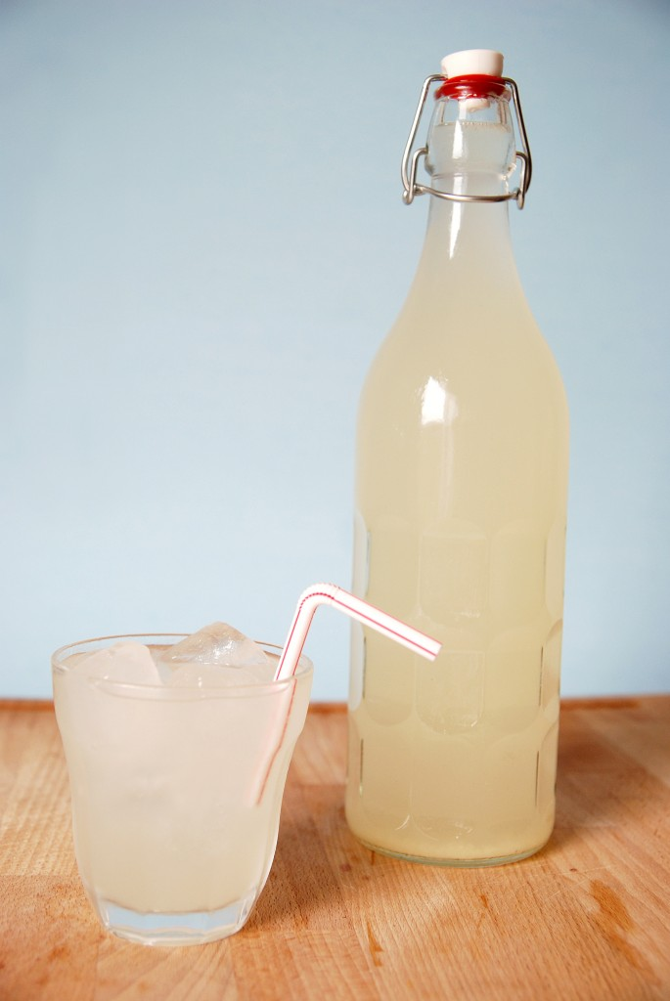
1 Gallon 3 Gallons 5 Gallons
Fresh ginger (about 6 inches long) 1 6” piece 3 6” pieces 5 6” pieces
Sugar 2 cups 6 cups 10 cups
Water – non-chlorinated as directed in recipe to fill carboy or vessel
Fresh lemons – medium juiced 2 4 6
Ginger Bug 1/2 cup 1 1/2 cups 2+ cups
Whey – fresh homemade 1/4 cup 1/2 cup 3/4 cup
The whey can be optional – No Whey! – most times I don’t add it.

INSTRUCTIONS:
There are many ways to make ginger ale. I attempt to understand the principles involved and then kind of work within those parameters. I will tell you how I make it and then give you some delicious variations.

- Fill the carboy or your brewing vessel up half way with cold or cool water. You cannot use tap water that is chlorinated as the chlorine will kill the microorganisms that cause the fermentation process to happen.
- Dissolve the sugar in water on the stove. Some recipes suggest that you need to heat up or boil at least half of the water, but I find this results in a lot of waiting for your temperature to come down before you can add the bug. I like to spend about 20 minutes total making ginger ale and so enough water to dissolve the sugar into a syrup is all that is needed.
- Pour your dissolved syrup (sugar water) into the vessel/carboy.
- Test the temperature – I use a digital thermometer that has a probe that can dip down into the carboy. Your temperature should be between 75° – 100° F.
- In a blender or food processor, blend your ginger mixed with enough water to make a watery slurry. Once blended, strain through a fine mesh strainer into the carboy. Repeat, by adding more water to existing ginger mash and strain again.
- Taste ginger ale for sweetness and ginger flavor.
- Add juice from fresh lemons. I usually add some, taste, add some more taste, etc. until it is just right. The lemons will add a flavor of freshness and take out the flat sugary taste.
- If the temperature is under 100°, you can add the strained ginger bug and the whey. The ginger bug or ginger starter is what will cause the fermentation process. The bacteria in the ginger will eat the sugar, creating lactic acid (very healthy!), lactobacilli probiotics and enzymes. The whey also offers probiotics and minimizes alcoholic fermentation. A teaspoon or two of sea salt can be added to increase the minerals, as well as, reduce alcohol from forming. I typically don’t use sea salt in my sodas.
- Taste again. To make a stronger ginger flavor – one that will give you a good ginger kick, add a ginger extract. I will often add a 2 ounce bottle of ginger tincture.
- Fill your bottle up to the gallon, 3 or 5 gallon mark. It is not necessary to fill it all the way up, but you want to make as much as you can, because once the kids start drinking it, it will go fast.
- Once satisfied with the taste, put on the airlock filled with water. Now, it is time for the microbes to do their job.
- Depending on the temperature, your ginger ale can ferment quickly or take its sweet time. During the summer, I’ve been able, on occasion, to bottle my ginger ale the next day. During winter and colder times, it can take two weeks. Depending on how fast it is fermenting, 2-5 days is usually enough time to create the optimum level of carbonation.
- You will begin to see small bubbles rising to the top of the jar and causing the airlock to out-gas the carbon dioxide.
- Taste the ginger ale periodically for the level of carbonation. When it is mildly carbonated, it is ready to bottle.
- Funnel into bottles, cap and label (We make up fun names and date each bottle) I like to use the bail-top bottles, but I know people who have used mason jars or gallon jugs. Refrigerate or put into a cool basement storage. Your ginger ale will continue to ferment and become more carbonated, but the cool temperature slows this process down. The soda continues to ferment in the bottles, giving off carbon dioxide gas. Since the bottles are sealed, the gas has nowhere to go. It stays in the bottle and makes the soda fizzy. Too much fermentation, not cool enough temperature and weak bottles can result in exploding bottles or bottles that will shoot foam all over when opening. One batch last summer shot a stream out of the bottle over 20 feet. As you drink your ginger ale, you may notice more carbonation with time.
- Drink it! Lacto-fermented soda is an excellent thirst quencher and contains beneficial lactic acid, vitamins, enzymes and beneficial lactobacilli that can inhabit your gut, where they protect you against pathogenic bacteria and yeast.

Variations: Plain old ginger ale is wonderful, but we really like:
Blueberry Bubbly – for 3 gallons add to cooking syrup 1 cup of powdered blueberry juice
Raspberry Ripple – for 3 gallons add to cooking syrup 1 cup powdered raspberry juice
Cherry Jubilee – for 3 gallons add to cooking syrup 1 cup powdered cherry juice
Raspberry Lemonade – omit the fresh ginger add more lemon and raspberry juice.
Ginger Ale – from your food storage – No fresh ginger or lemons available?
Substitute 1/4 cupof dried ginger pieces (cut & sifted) for each gallon of finished product. Boil the ginger inwater for 20 minutes to make a strong decoction. Strain and add to your syrup (dissolvedsugar). Add reconstitute lemon from a bottle in place of the fresh lemons. Admittedly,this is not as wonderful, but it is still pretty darn delicious.

Root Beers
Root beer is made following the same principles as the ginger ale directions, just with a different recipe. There are endless varieties. Here are a couple root beer recipes that we like.

Sassparilla
This combines the herbs sassafras and sarsaparilla = Sassparilla

INGREDIENTS:
1 Gallon 3 Gallons 5 Gallons
Sarsaparilla - cut herb 1/2 oz. 1 oz. 2 oz.
Sassafras root – cut root 1/4 oz. 1/2 oz. 1 oz.
Licorice root – cut root 1/8 oz. 1/4 oz. 1/2 oz.
Boil these herbs in water for at least 20 minutes to extract the herbal goodness and flavor.
Sugar 2 cups 6 cups 10 cups
Water – non-chlorinated as directed in recipe to fill carboy or vessel
Fresh lemons – medium juiced 2 4 6
Ginger Bug 1/2 cup 1 1/2 cups 2+ cups
Whey – fresh homemade 1/4 cup 1/2 cup 3/4 cup
Molasses * 1Tbs. 3Tbs 5Tbs. or to taste
Add the strained herbal extract to the syrup (dissolved sugar) and follow ginger ale recipe directions.

Birch Beer
INGREDIENTS:
1 Gallon 3 Gallons 5 Gallons
Birch bark- cut herb 1/2 oz. 1 oz. 2 oz.
Sassafras root – cut root 1/4 oz. 1/2 oz. 1 oz.
Licorice root – cut root 1/8 oz. 1/4 oz. 1/2 oz.
Boil these herbs in water for at least 20 minutes to extract the herbal goodness and flavor.
Sugar 2 cups 6 cups 10 cups
Water – non-chlorinated as directed in recipe to fill carboy or vessel
Fresh lemons – medium juiced 2 4 6
Ginger Bug 1/2 cup 1 1/2 cups 2+ cups
Whey – fresh homemade 1/4 cup 1/2 cup 3/4 cup
Molasses * 1Tbs. 3Tbs. 5Tbs. or to taste

Sometimes, I will add birch essential oil to the finished brew before we set it out for fermentation. I add several drops, taste, add some more, until it’s just right. I’m a firm believer in the taste as you go method.

*All molasses is not created equal – find one that you like and tastes good to you. I like Grandma’s and don’t like blackstrap in my rootbeer.

One final thing:

Several of you expressed an interest in the Healing book. You may click on the link below for a free download. We will send out an email when we get printed copies of the book or you are free to have copies made by a

Please review the table of contents and go from there.
Here is a book that you will be interested in. It is a free download by clicking on the link below.
EBook: Healing begins with Sanctification of the Heart. Written by an orthodpedic surgeon (Michelle Strydom MD) in Zimbabwe. The books is massive - 700+ pages. A serious study of this is well worth our time.
Click on link
http://www.eagleswings.co.zw/Free%20Books/Sanctification%20of%20the%20Heart%204th%20Edition.pdf

Additionally, you may be interested in the Podcasts of Mike Stroud. He is a retired institute instructor and teaches the gospel beautifully teaching gospel principles that you will never discuss in Sunday school.

http://mstroud.podomatic.com/

For additional information from me you can visit my You Tube channel, webpage or Blog.

https://www.youtube.com/channel/UCF0nLcjT_EGe5IiOyF0o1Vw

http://drkylechristensen.net/

http://drkylechristensen.blogspot.com/

Blessings,

Dr. Kyle D. Christensen
125 West Oak Drive

Woodland Hills, UT 84653
(801) 360-0749
kylesinthegarden@gmail.com

